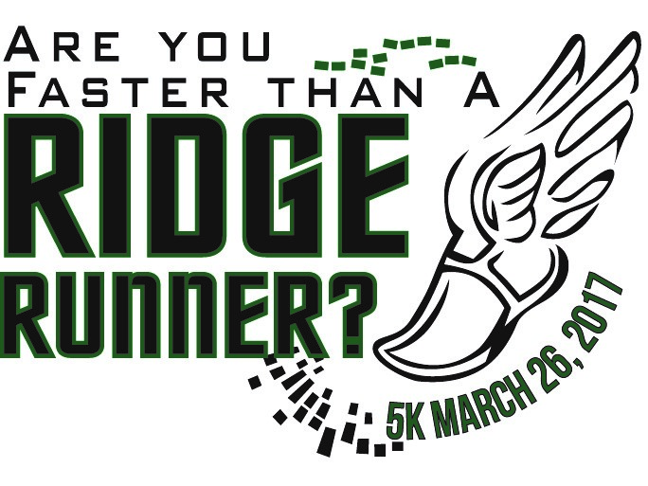

Mountain Park, Basking Ridge, NJ

To Sign Up Go To RunSignUp.Com
Find a Race: Are You Faster…

